Corey Gaspar
2/1/2026
4-1 Milestone: Create and Read in Python
I imported the CRUD module to access the AnimalShelter class. Next, I created an instance of the AnimalShelter class named shelter. The “aacuser” credentials were passed through the CRUD module that was imported in the command prior.
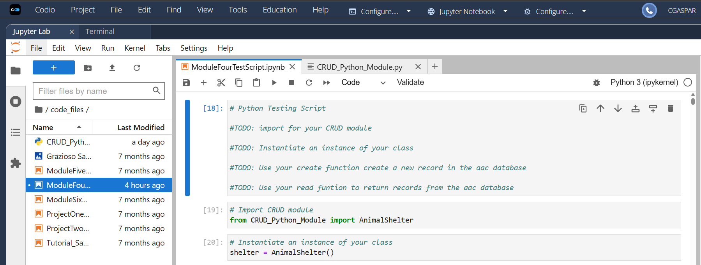
I then used the create function to create a new record in the AAC database. I inserted the document into MongoDB and tested.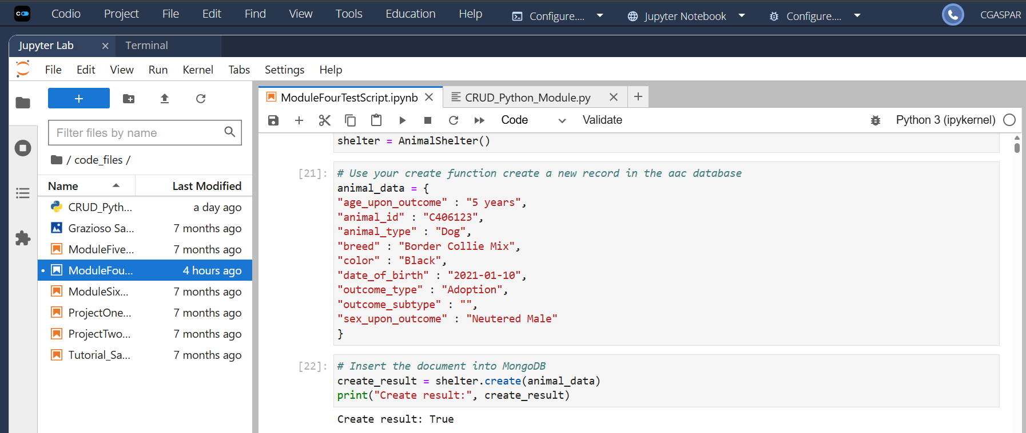
I tested the read function by querying a search for animals of the type “Dog”. The query is then passed to the read method, which returns matching records from the database. I then displayed the results of each animal record.
